Warm-Up: Promise of Emancipation

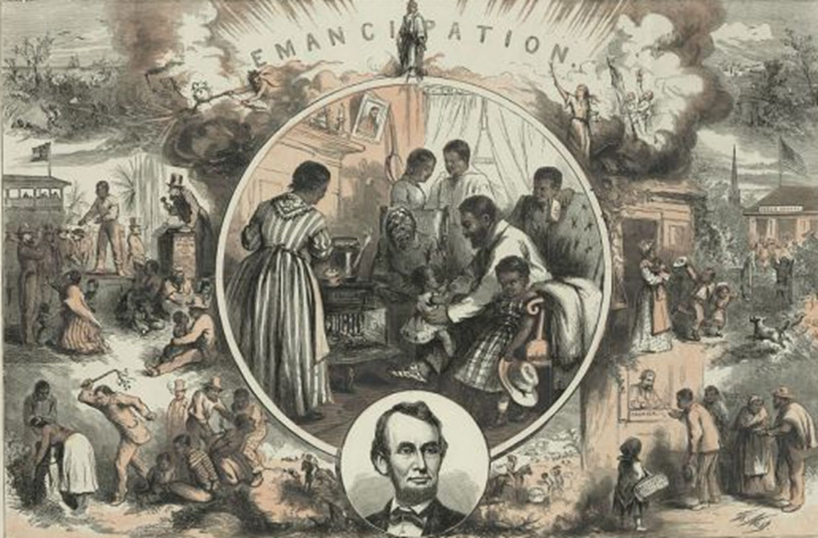

Imagine what would happen next in the life of a freed slave.

- Where would they go? What would they need or want?

- How would they live? What skills would they need to acquire?

- Do you think the right side of this image is an accurate portrayal of life after slavery?

- What would it take to transform the lives of African Americans from the life portrayed on the left side of this image to the life portrayed on the right?

